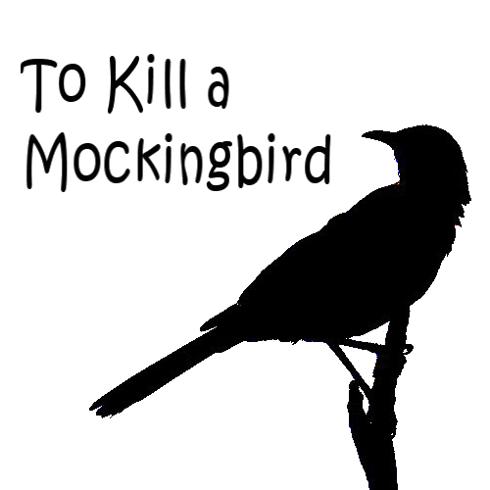
Chapter Expert Assignment

You and your partner are the Chapter Experts of your assigned chapter. What do you need to do? Read the chapter! And, make sure you really know all the details. In approximately 5 minutes, you will:
- Present your ‘creative’ one line chapter title that cleverly captures the action of the chapter
- Quick summary – just the facts!
- Significant/favorite quote – then, explain its significance. Does it reinforce a theme? Character trait? Or something else?

You will present this information to the class (whatever format you choose). Please also type up this information and put in your Google folder so I can grade.

