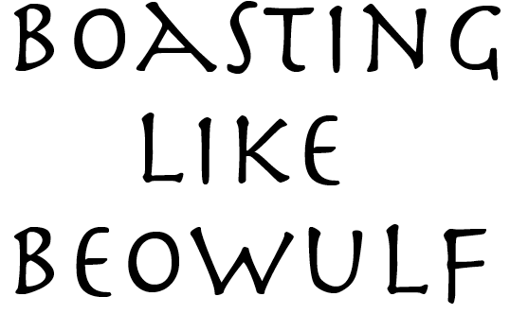

\* who you are related to

+ accomplishments

BOLD CAPS your deed

Underline kennings

Comma indicate caesura

Here are the directions for marking your Boast!